AUTO - CAD

LAB REPORT
FILE

NAME-ASHISH DHYANI
CIVIL- 5th semester
14541

REPORT ON 2D PLAN-
PLAN BRIEFING-
IN THIS 2D AUTO CAD PLAN, I HAVE MADE A 2-BHK FLAT PLAN.
THE SPECIFICATIONS OF THE 2-BHK FLAT ARE AS FOLLOWS:

TYPE- 2 BHK
SUPER AREA-1360 SQ. FT.
NUMBER OF ROOMS- 4 (MASTER BED ROOM 12’-0”X15’-0”
, BED ROOM 12’-0”X12’-6”
, LIVING ROOM 19’-3”X12’-0”
, DRESSING ROOM 6’-0”X6’-0”)
TOILET- 2 (6’-0”X6’-0” & 6’-0”X8’-6”)
DINING HALL-1 (10’-6”X8’-6”)
KITCHEN – (7’-6”X12’-3”)
WITH SOME HOUSE HOLD ITEMS.

IN THE 2D DRAWINGS I HAVE SHOWN TOP VIEW, SECTIONAL VIEW, AND ELEVATION OF THE PLAN.
THE FLAT IS INTENDED FOR A SMALL FAMILY OF 3 TO 4 MEMBERS.
REPORT ON 3D PLAN-
PLAN BRIEFING-
IN THIS 3D AUTO CAD PLAN, I HAVE MADE A 2-BHK FLAT PLAN.
THE SPECIFICATIONS OF THE 2-BHK FLAT ARE AS FOLLOWS:

TYPE- 2 BHK
SUPER AREA-1360 SQ. FT.
NUMBER OF ROOMS- 4 (MASTER BED ROOM 12’-0”X15’-0”
, BED ROOM 12’-0”X12’-6”
, LIVING ROOM 19’-3”X12’-0”
, DRESSING ROOM 6’-0”X6’-0”)
TOILET- 2 (6’-0”X6’-0” & 6’-0”X8’-6”)
DINING HALL-1 (10’-6”X8’-6”)
KITCHEN – (7’-6”X12’-3”)
IN THE 3D DRAWINGS I HAVE SHOWN TOP VIEW, SECTIONAL VIEW, AND ELEVATION OF THE PLAN.
THE FLAT IS INTENDED FOR A SMALL FAMILY OF 3 TO 4 MEMBERS.

COMMANDS USED IN 2D AND 3D
- Copy: Draws a copy of selected objects using two methods -- "base point" method, or "displacement" method.
- CLOSE: Closes the current drawing.
- COLOR: Defines color for new objects.
- DTEXT: Draws text "Dynamically" so that as you enter text letters or numbers, they are visible on the screen
- DIMLINEAR: Creates linear dimensions.
- ERASE: Erases selected entities from the drawing.
- EXTEND: Lengthens a line, arc, or polyline to meet a specified "boundary edge".
- EXTRUDE: Creates unique solid primitives by extruding existing two-dimensional objects.
- HATCH: Fills a specified boundary with a pattern.
- LAYER: Creates named drawing layers, assigns color and line type properties to those layers, allows layers to be frozen and thawed, locked and unlocked, and allows current layer to be set.
- LINE: Draws straight lines.
- MIRROR: Reflects designated entities about a user-specified axis.
- MOVE: Moves designated entities to another location.
- OFFSET: Creates a new line, polyline arc or circle parallel to the entity and at a specified distance from it.
- ORTHO: Constrains drawing so that only lines aligned with the grid can be drawn -- usually means only horizontal or vertical lines, however, if the crosshairs are rotated through the "Snap" "Rotate" command sequence, the lines drawn are constrained to being parallel with the crosshair rotation. Constraint can be overridden by snapping to a point or by entering exact coordinates for endpoints.
- OSNAP: object snap modes
- PAN: Moves the display window without changing the magnification factor.
- PLINE: Draws a 2D polyline, which are connected line or arc segments with user-determined width and taper.
- PRESS/PULL: Does the same thing as the extrude command.
- PROPERTIES: Controls properties of existing objects.
- QUIT: Exits AutoCAD.
- RECTANG: Draws a rectangular polyline.
- ROTATE3D: Moves objects about a base point.
- REDO: Reverses the effects of the previous UNDO or U command.
- REDRAW: Refreshes the display in the current viewport
- SCALE: Alters the size of existing objects.
- SHADE: Shades the objects in the current viewport.
- SNAP: Restricts cursor movement to specified intervals.
- STRETCH: Moves or stretches objects.
- TEXT: Draws text characters of any size with selected styles.
- TRIM: Erases a portion of selected entities that cross a specified "cutting edge".
- UNDO: Reverses the effect of multiple commands, and provides control over the "Undo" facility.
- VPOINT: Sets the viewing direction for a three-dimensional visualization of the drawing
- XREF: Controls external references to drawing files.
- BOX: Creates a three-dimensional solid box.
- BOUNDARY: Creates a region or a polyline from an enclosed area.

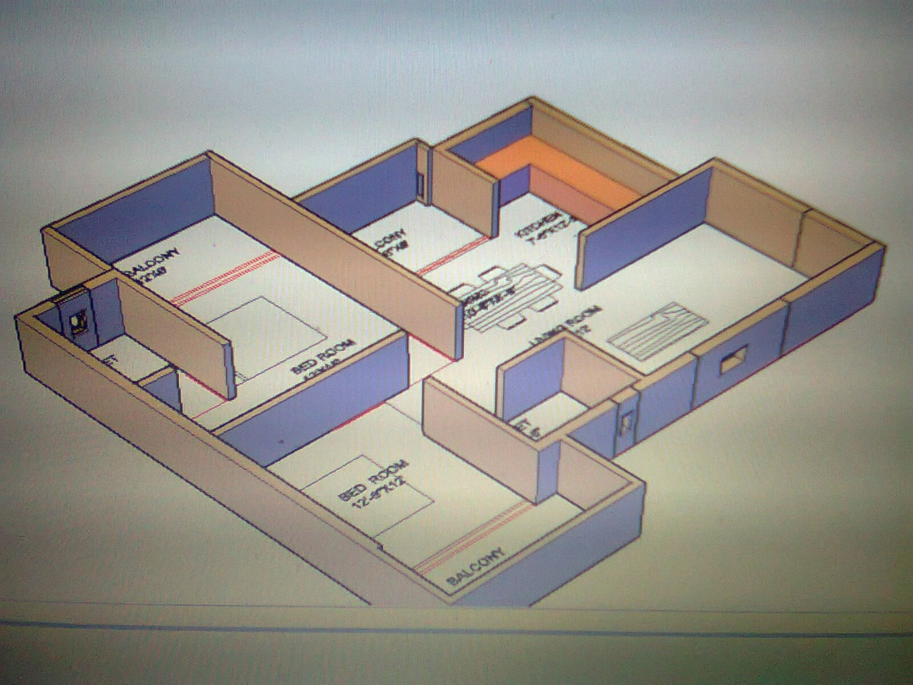
FIG: 3D PLAN

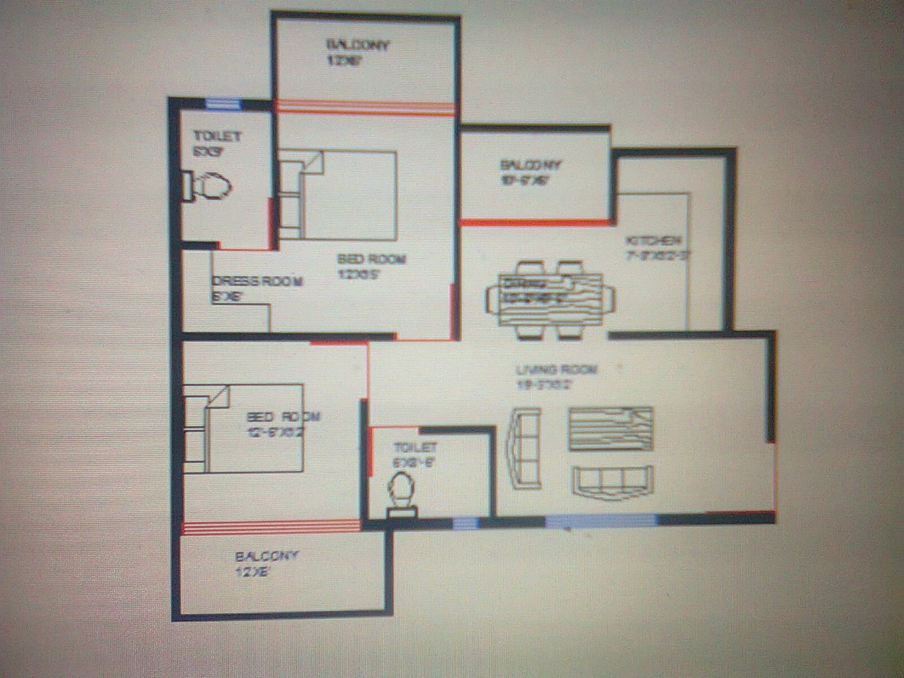
FIG 2D PLAN

